Clone Repository to File Path with the least length (Like “D:\Repo”) or make sure OS supports long file paths, cause there may be issues with build.
UI Framework Configuration
SELENIUM (used new Selenium feature of automatic driver resolution – use SeleniumWebDriverFactory.cs as example for configuration)
PLAYWRIGHT
- Install Node.js https://nodejs.org/en/download/current
- Build “Tests.DevQAProdCom.Core.UI”
- Go to “Tests.DevQAProdCom.Core.UI\bin\Debug\net8.0” , open PowerShell and execute “pwsh playwright.ps1 install” – it will install browsers

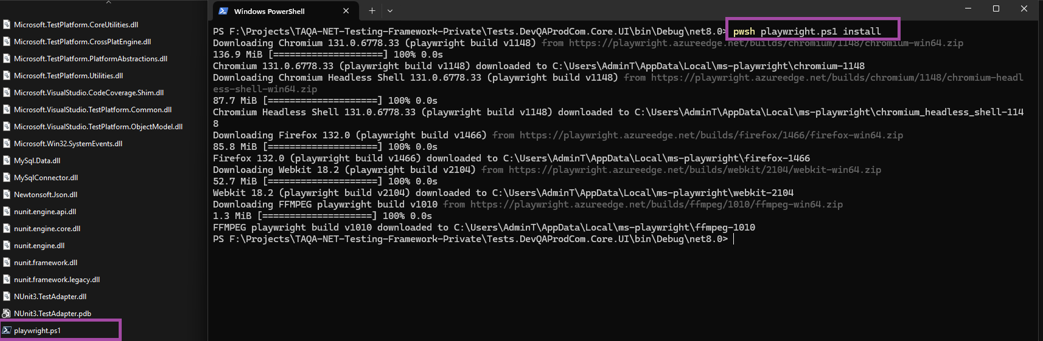
AngularApp (for testing UI Framework functionality – angular app repo will be added later)
- Go to “AngularApp\ClientApp”
- Open PowerShell and execute “npm install” – it will download necessary libraries to run UI Test Application for testing UI Framework functionality
- Run “npm run start”
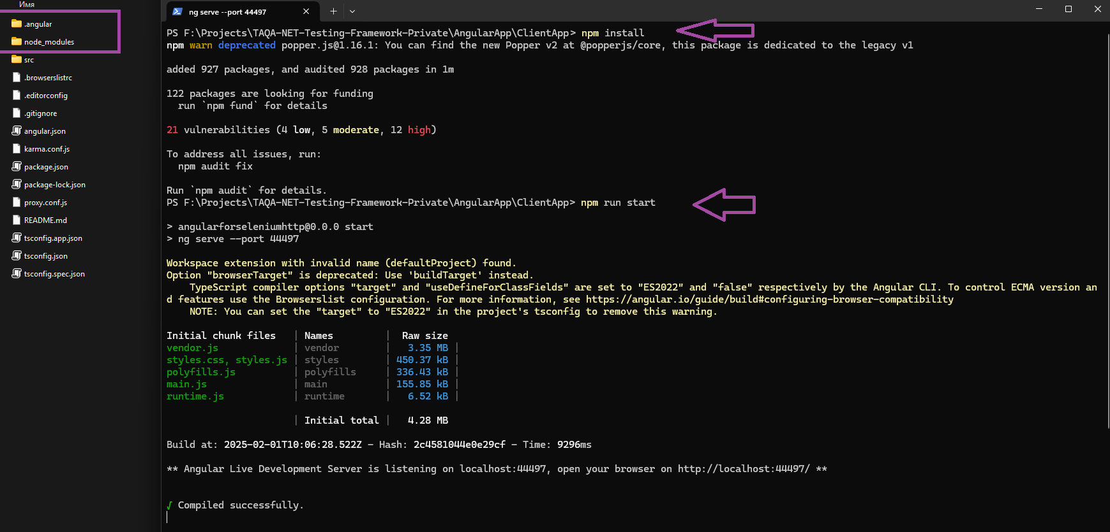

- Go to http://localhost:44497/LoginTestPage to check that test app is launched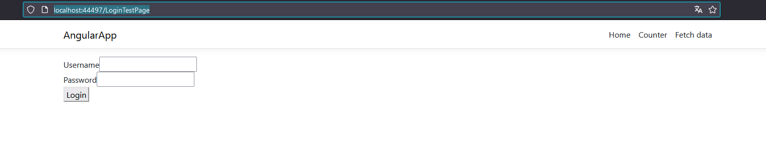
LAUCH UI TESTS
- Go to “Tests.DevQAProdCom.Core.UI.DependencyInjection.DI.cs”
- Select technology “Selenium” or “Playwright” and run test, for instance “Ui_Tests_Should_Login”
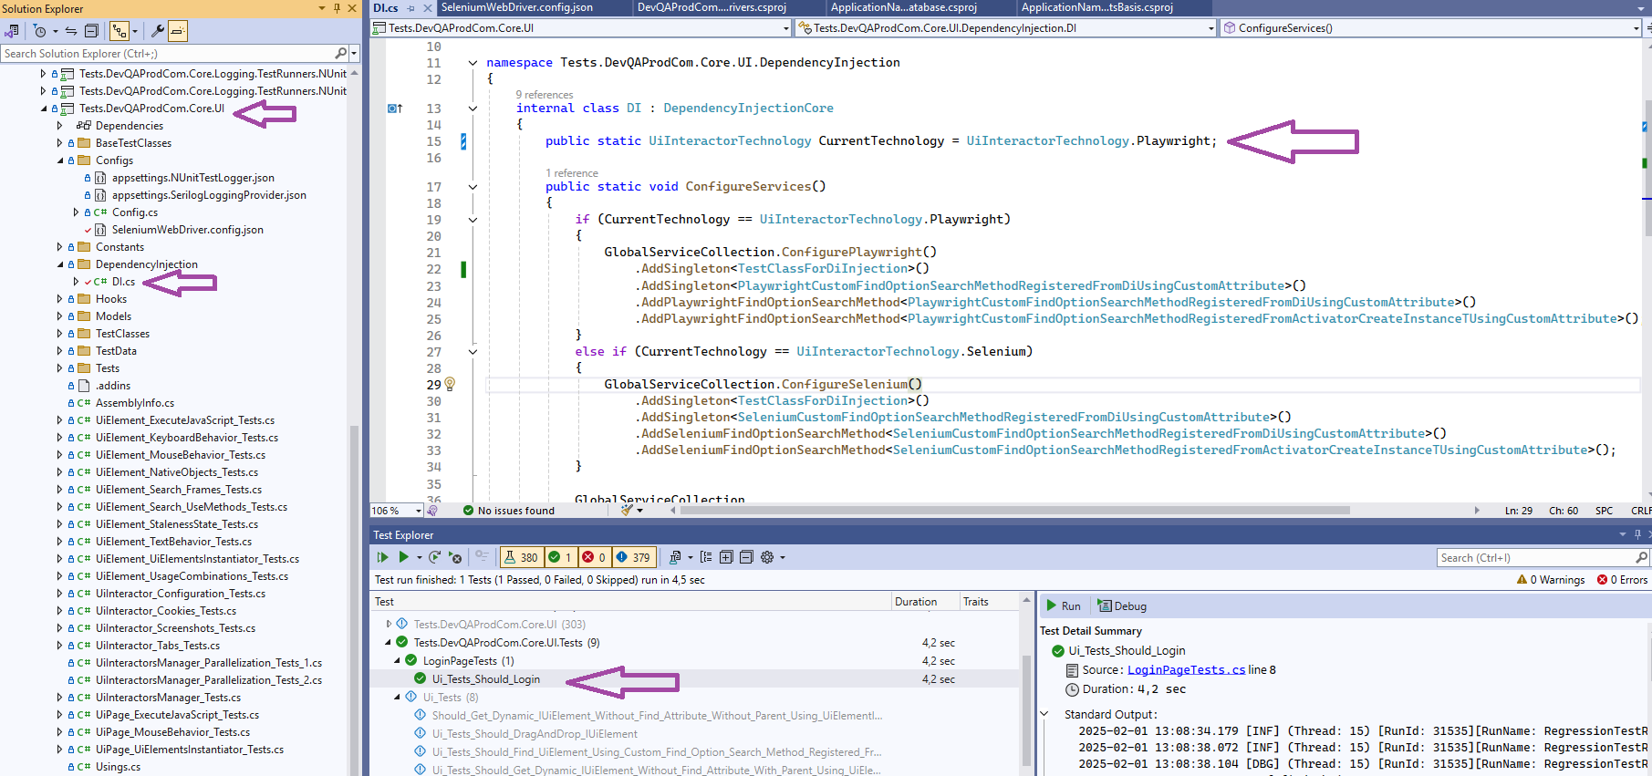
Logging Configuration
- Configure DI with appropriate project references
<ItemGroup>
<ProjectReference Include="..\DevQAProdCom.Core.Logging.Providers.Serilog\DevQAProdCom.Core.Logging.Providers.Serilog.csproj" />
<ProjectReference Include="..\DevQAProdCom.Core.Logging.TestRunners.NUnit\DevQAProdCom.Core.Logging.TestRunners.NUnit.csproj" />
</ItemGroup>

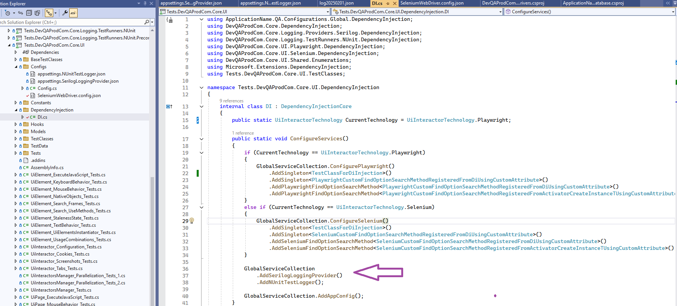

- Add NUnit “.addins” file
DevQAProdCom.Core.Logging.TestRunners.NUnit.dll
Tests.NUnit.Extension.ProjectLoader.dll
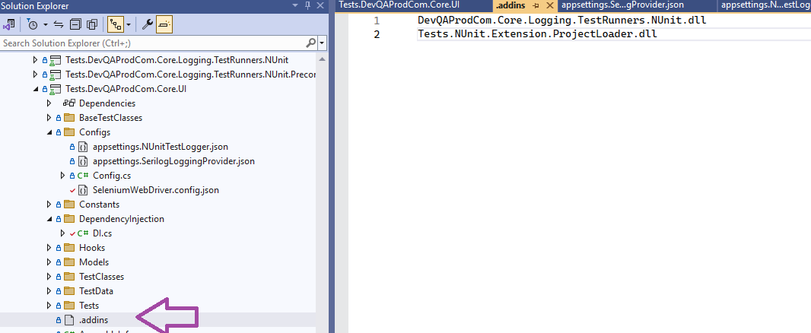
- Check files in “Configs” folder. Make sure to set their states to “Copy Always” or “Copy if newer” so that they to be copied to “bin” folder during the build.
“appsettings.NUnitTestLogger.json”
{
"nUnitTestLogger": {
"testRunId": "ManuallySetTestRunId",
"testRunName": "ManuallySetTestRunName",
"testRunDescription": "ManuallySetTestRunDescription",
"versionUnderTest": "ManuallySetVersionUnderTest",
"writeMode": [ "SingleLogFilePerRun" ]
}
}

“appsettings.SerilogLoggingProvider.json”
{
"Serilog": {
"Using": [ "Serilog.Sinks.Seq" ],
"MinimumLevel": {
"Default": "Verbose",
"Override": {
"Microsoft": "Verbose",
"System": "Verbose"
}
},
"WriteTo": [
{
"Name": "Console",
"Args": {
"outputTemplate": "{Timestamp:yyyy-MM-dd HH:mm:ss.fff} [{Level:u3}] (Thread: {ThreadId}) {Message:lj}{NewLine}{Exception}"
}
},
{
"Name": "Seq",
"Args": {
"serverUrl": "http://localhost:5341",
"apiKey": "ZvKL6rLaLYBz7WRwGJa2",
"batchPostingLimit": 1000,
"queueSizeLimit": 100000,
"period": "0.00:00:01"
}
},
{
"Name": "File",
"Args": {
"path": "Logs/log.txt",
"rollingInterval": "Day",
"outputTemplate": "{Timestamp:yyyy-MM-dd HH:mm:ss.fff} [{Level:u3}] (Thread: {ThreadId}) {Message:lj}{NewLine}{Exception}"
}
},
{
"Name": "File",
"Args": {
"formatter": "Serilog.Formatting.Compact.CompactJsonFormatter, Serilog.Formatting.Compact",
"path": "Logs/log.json",
"rollingInterval": "Day"
}
}
],
"Enrich": [ "FromLogContext", "WithMachineName", "WithProcessId", "WithThreadId" ]
}
}
Logs are added to "Logs/log.txt" and "Logs/log.json" files in bin folder. Also Seq can be installed https://datalust.co/seq or any other logs querying system that Serilog supports. For Seq, be careful with the following configuration options, because they influence how often and in what batches logs are sent to Seq.
"batchPostingLimit": 1000,
"queueSizeLimit": 100000,
"period": "0.00:00:01"

- SetUp RunHooks - Log.SetTestRunLogInfo
IoHelper.CleanDirectory("Logs");
Log.SetTestRunLogInfo(testRunId: $"RunId: {Guid.NewGuid().ToString().Substring(0,5)}",
testRunName: "RunName: RegressionTestRun",
versionUnderTest: "Version: v0.3");

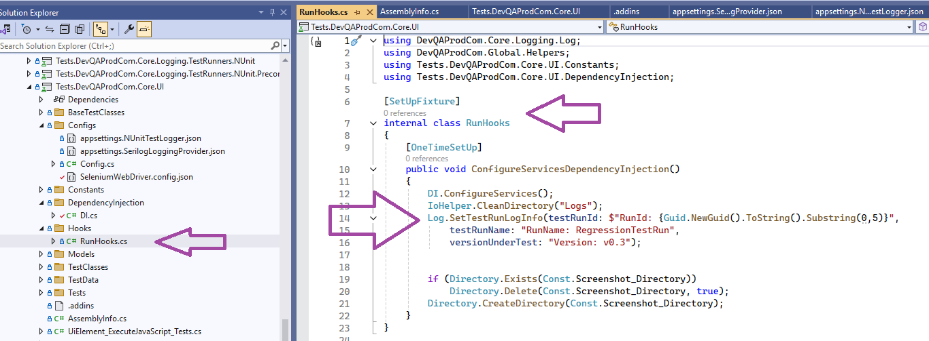
- SetUp BaseTest - Log.LogTestStart

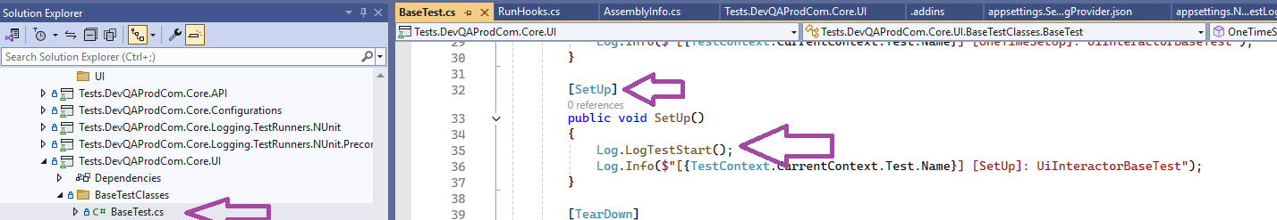

After running tests, logs can be found in “Tests.DevQAProdCom.Core.UI\bin\Debug\net8.0\Logs” folder and in Seq (it is installed and configured – as is or with api keys)